Founder Single MLE
Let
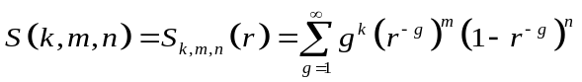,
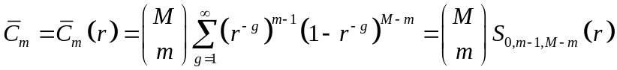
for 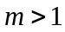. Define 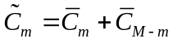 for 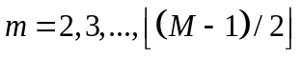, and in addition, 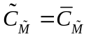 if  is even. The profile likelihood for is
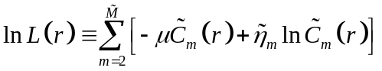,
with Fisher information
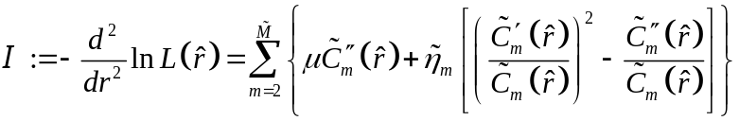.
Using the Fisher information 

